**Online LabTests Booking**



Team Members:

Sreepranav (Team Lead, Front End Developer and Back End Developer)

Vamshi Krishna Reddy (Designer)

Harini (Front End Developer)

Sruthi (Web Designer)

**Online LabTests Booking**

Introduction

Indus Health is a web-based application developed using Java programming language. It mainly focuses on placing lab tests easily using internet. Admin and customers all will have different interface and different privileges according to their needs.

A customer can only manage his account and cannot see any details of other customers. Admin can see the details of all customer accounts. Admin can process the orders placed by the customers.

Objective

* To develop an online website to place medical tests.
* Provide easy way to do the lab tests at home

Functionalities provided:

* Place required medical tests.
* View the status of test.

Modules

There will be two main interfaces for our website. One is for admin and the other is for the user, here user is a customer.

Registration Page:

Through this page, new user can easily register himself/herself on website. In this page, user will enter their necessary data.

Login Page:

Through this page, a registered user can login by entering their username and password. If user enters wrong credentials they cannot be able to login to main page.

Main page:

There will be two section in main page. One is to place an order and the other one is to view their order.

Place an order:

In this page, user can book required tests which are available by entering some necessary data.

View orders:

In this page, user can check their orders which are placed previously.

Admin page:

By using this page, admin can update the status of order which are placed by user.

Update Order page:

In this page admin can update the status of order which was placed by user/customers.

Technologies Used

Frontend and Backend are the two most popular terms used in web development. These terms are very crucial for web development but are quite different from each other. Each side needs to communicate and operate effectively with the other as a single unit to improve the website’s functionality.

Front End:

The part of website that the user interacts with directly is termed the front end. It is also commonly referred to as the ‘client side’ of the application. It includes everything that users experience directly.

HTML:

HTML stands for Hyper Text Markup Language. It is used to design the front-end portion of web pages using a markup language. HTML is the combination of Hypertext and Markup language. Hypertext defines the links between the web pages. The markup language is used to define the text documentation within the tag which defines the structure of web pages.

CSS:

CSS stands for Cascading Style Sheet. CSS is a simply designed language intended to simplify the process of making web pages presentable. It is responsible for the style of web pages including colors, layouts and animations. CSS is used to format the layout of web pages.

JavaScript:

JavaScript is a famous scripting language used to create magic on the sites to make the site interactive for the user. It is used to enhance HTML pages and is commonly found embedded in HTML code. JavaScript is an interpreted language. Thus, it doesn’t need to be compiled. JS renders webpages in an interactive and dynamic fashion.

Back End:

Back-end is the server-side of the website. It stores and arranges data and also make sure everything on the client-side of the website works fine. It is the portion of software that does not come in direct contact with the user.

Four Main Components of Backend Development

Server

API

Database

Programming

Language

Java (Programming Language):

Java is one of the most popular and widely used programming languages and platforms. It is a general-purpose, class-based, object-oriented programming language designed for having lesser implementation dependencies. It is highly scalable. Java components are easily available.

Apache Tomcat (Server):

Apache Tomcat is an open source Java servlet container that implements many Java Enterprise Specs such as the Websites API, Java-Server Pages(JSP) and Java Servlet. The initial idea of Tomcat software was to host and deploy the Java servlet that is the server-side Java code that manages HTTP results from client applications build using Java.

Hibernate (API/ORM):

Hibernate is a high-performance Object/Relational persistence and query service, which is licensed under the open source GNU Lesser General Public License (LGPL) and is free to download. Hibernate not only takes care of the mapping from Java classes to database tables (and from Java data types to SQL data types), but also provides data query and retrieval facilities. This tutorial will teach you how to use Hibernate to develop your database based web applications in simple and easy steps.

Oracle (Database):

Oracle database is a Relational DataBase Management System (RDBMS) from Oracle Corporation. It allows us to access, manage, store and find relevant information.

Project Life Cycle

Agile Software Development Methodology:

Agile is the ability to create and respond to change. It is a way of dealing with, and ultimately succeeding in, an uncertain and turbulent environment.

Agile software development is an umbrella term for a set of frameworks and practices based on the values and principles expressed in the Manifesto for Agile Software Development and the 12 Principles behind it.

Agile Software Programming Practices:

1. Test-first programming (or perhaps Test-Driven Development).
2. Rigorous, regular refactoring.
3. Continuous integration.
4. Simple design.
5. Pair programming.
6. Sharing the codebase between all or most programmers.
7. A single coding standard to which all programmers adhere.
8. A common “war-room” style work area.
9. Such practices provide the team with a kind of Tai Chi flexibility: a new feature, enhancement, or bug can come at the team from any angle, at any time, without destroying the project, the system, or production rates.

Agile SDLC’S:

1. Speed up or bypass one or more life cycle phases.
2. Usually for time –critical applications.
3. Used for time- critical application.
4. Used in organizations that employ disciplined methods.

Phases of extreme programming:

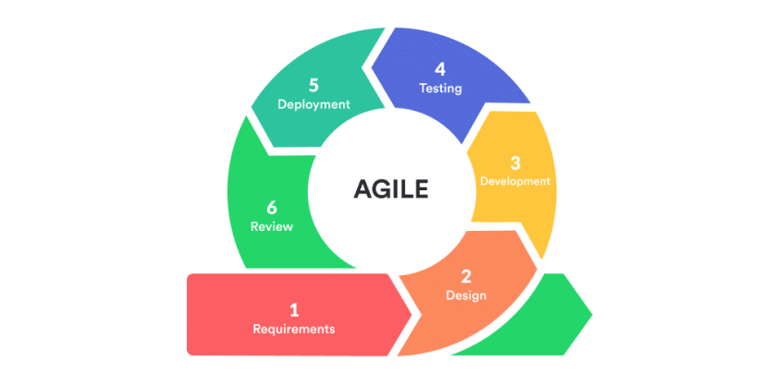

There are 6 phases available in Agile XP method and those are explained as follows:

Planning:

* Identification of stakeholders and sponsors
* Infrastructure Requirements
* Security related information and gathering
* Service Level Agreements and its conditions

Analysis:

* Capturing of Stories in parking lot
* Prioritize stories in parking lot
* Scrubbing of stories for estimation
* Define Iteration SPAN(Time)
* Resource planning for both Development and QA teams

Design:

* Break down of tasks
* Test scenario preparation for each task
* Regression Automation Framework

Execution:

* Coding
* Unit Testing
* Execution of Manual test scenarios
* Defect Report generation
* Conversion of Manual to Automation regression test cases
* Mid Iteration review
* End of Iteration review

Wrapping:

* Small Releases
* Regression Testing
* Demos and reviews
* Develop new stories based on the need
* Process Improvements based on end of iteration review comments

Closure:

* Pilot Launch
* Training
* Production Launch
* SLA Guarantee assurance
* Review SOA strategy
* Production Support

ER Diagram

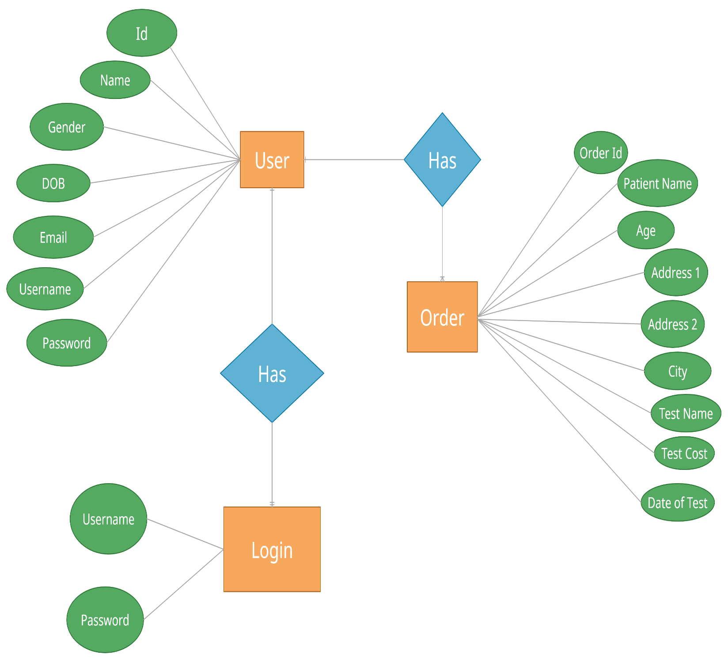

Snapshots

Registration Page

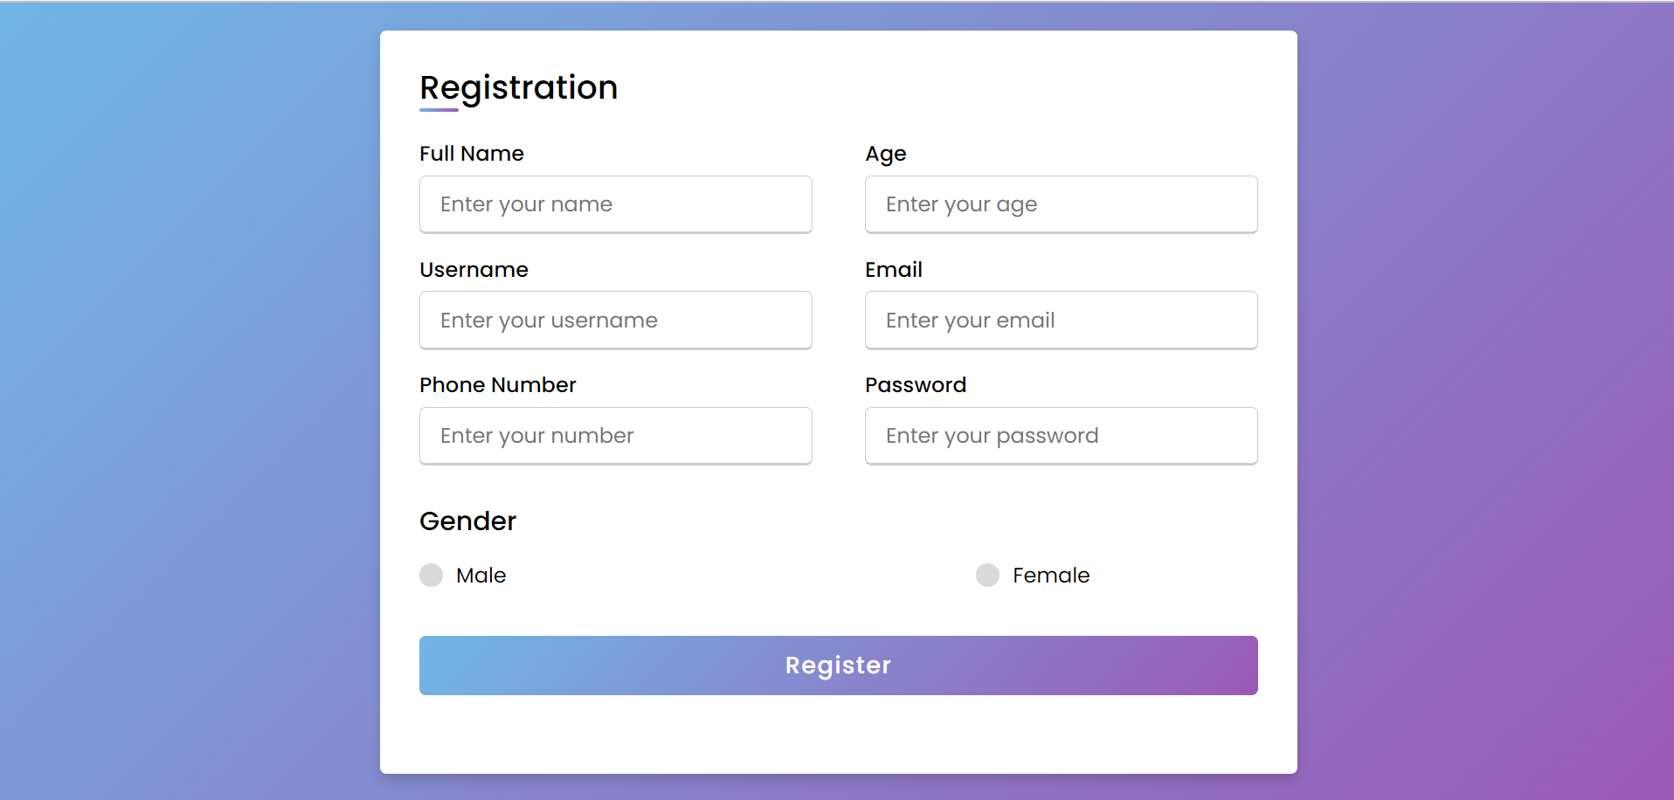

Login Page

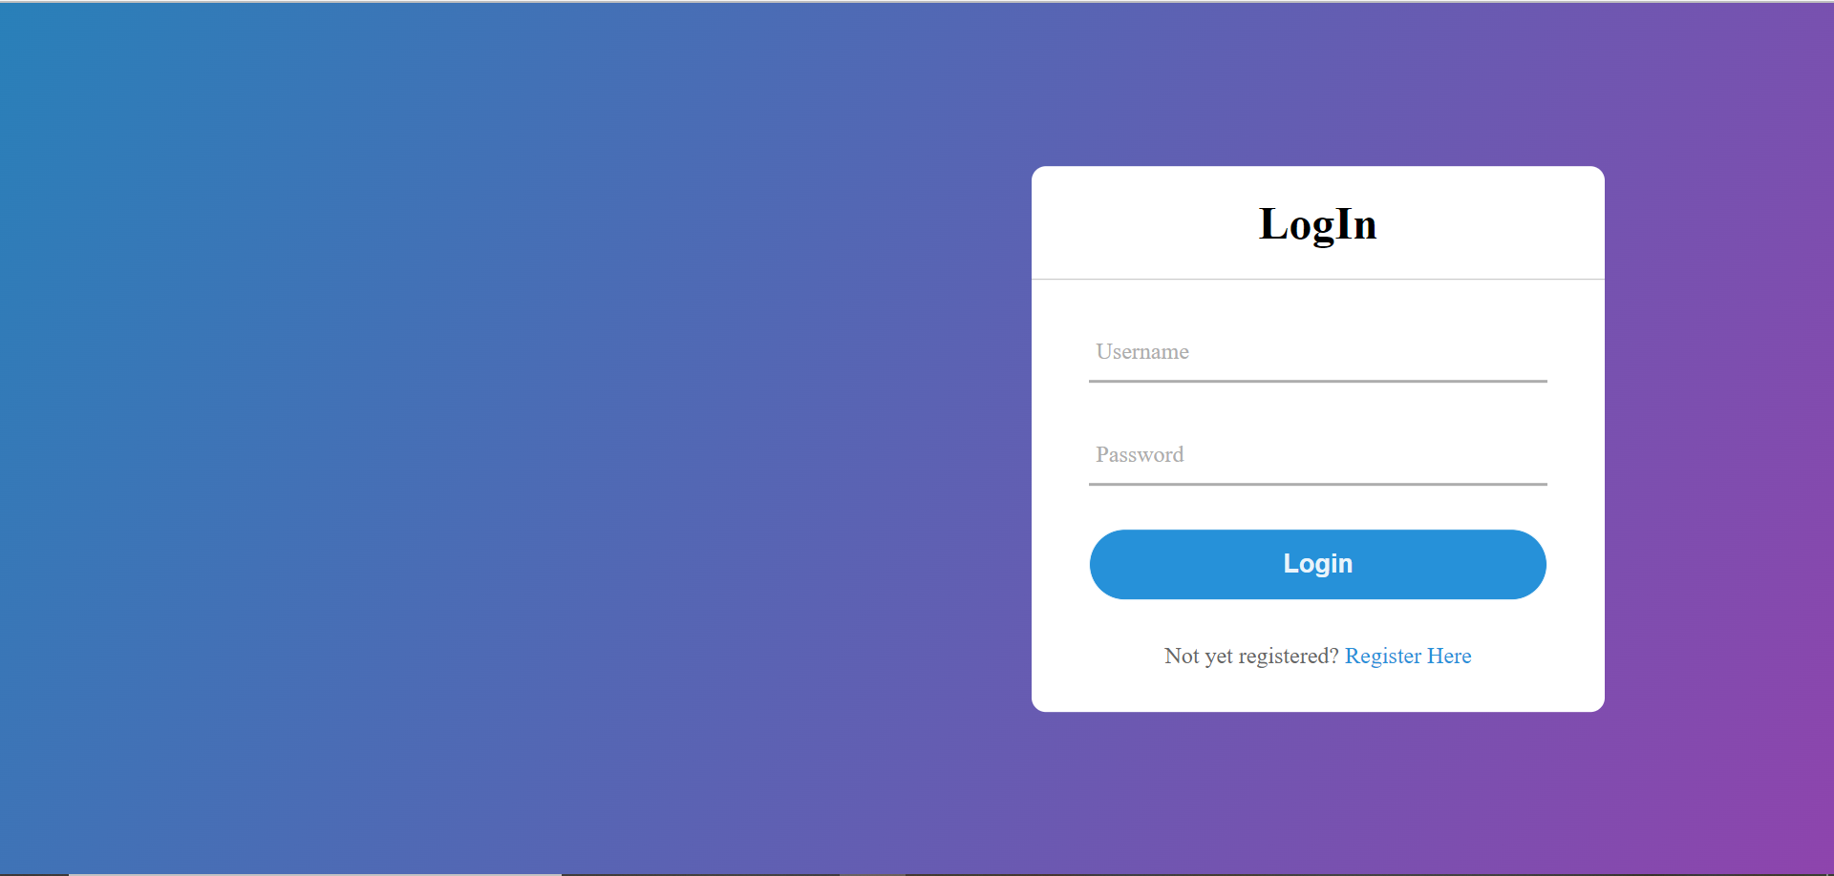

User Home Page

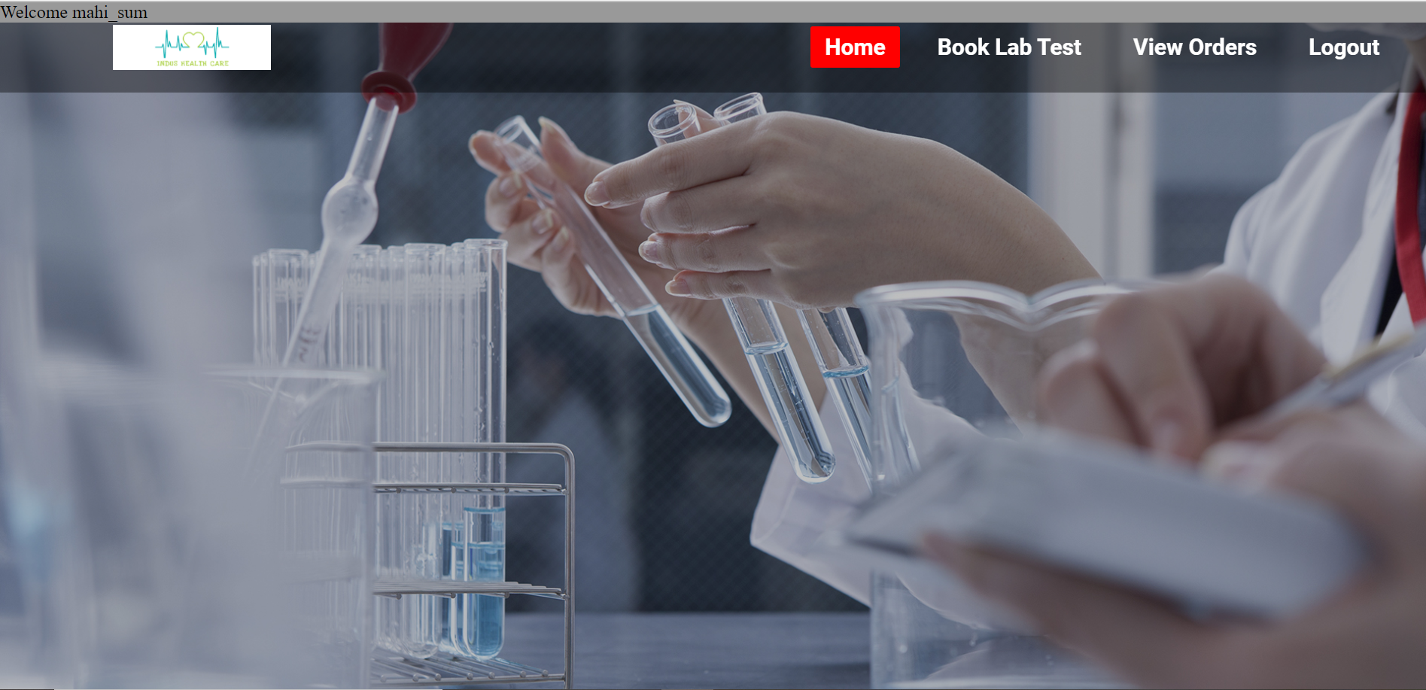

Test Booking Page

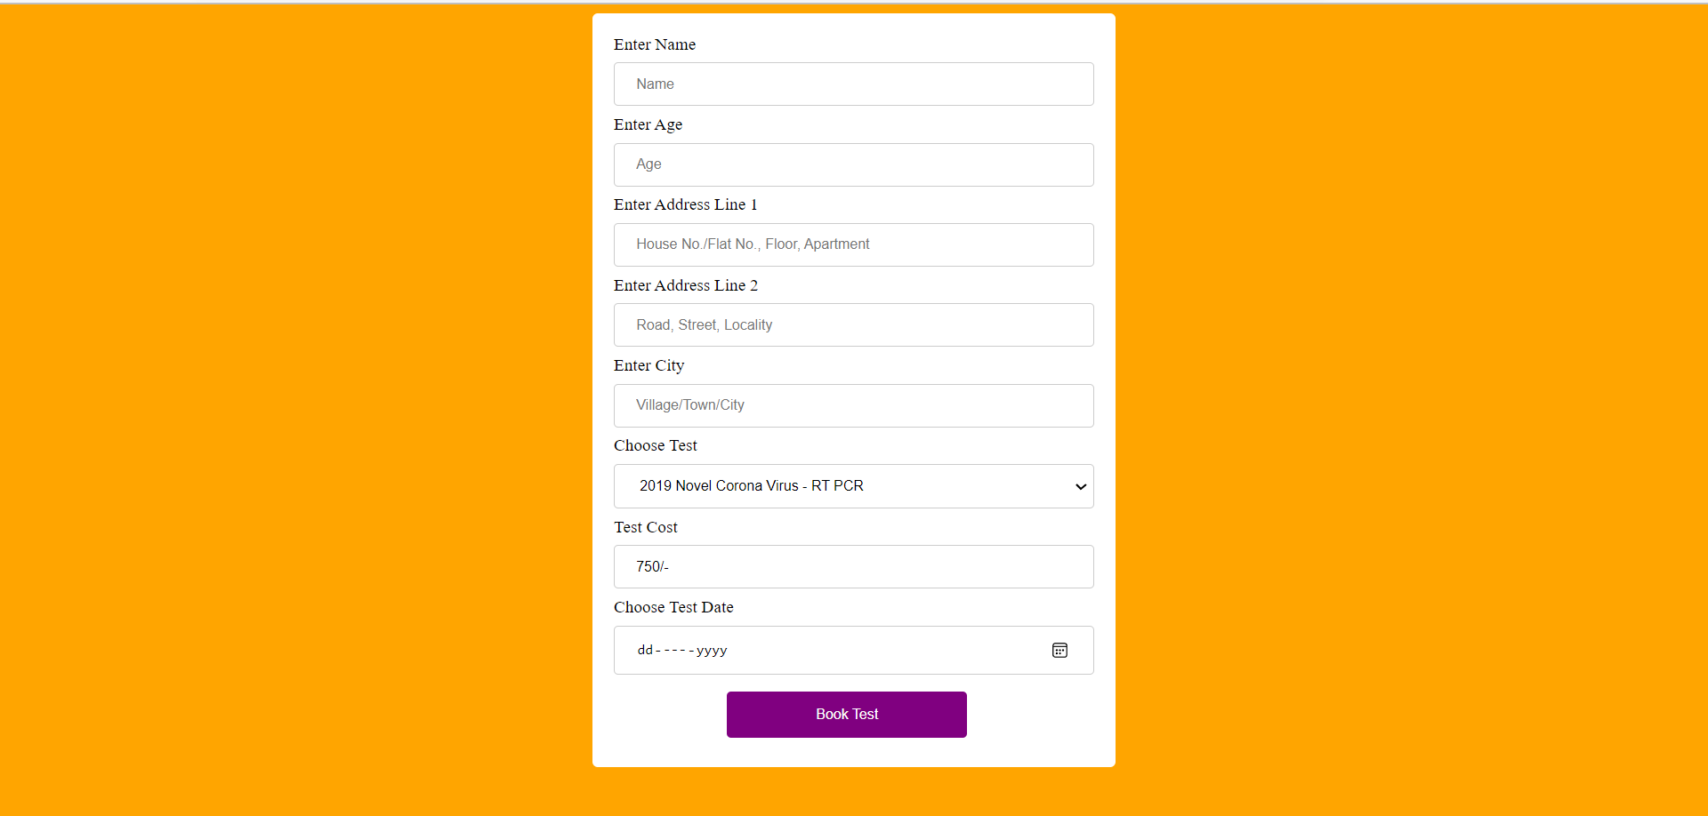

Admin Home Page

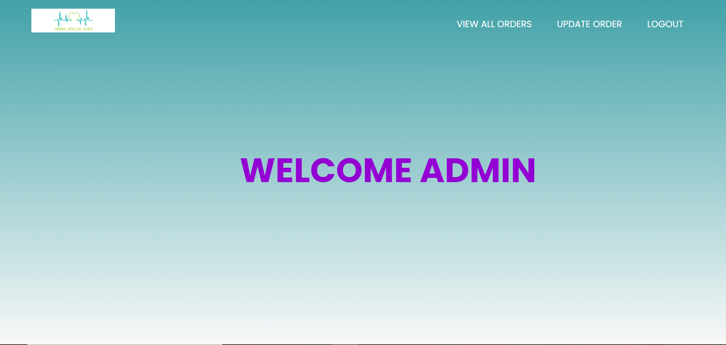

Order Update Page

